**CSE 170 - Java Basics with OOPs**

**PROJECT REPORT**

|  |  |
| --- | --- |
| **Name :** | Ayushmaan Das |
| **Unique ID :** | E0121037 |
| **Year :** | I |
| **Quarter :** | Q2 |
| **Department :** | B.Tech AI/ML |
| **Faculty Name :** | Prof. Ramya M |
| **Academic Year :** | 2021-2022 |

***QUIZ APPLICATION using JSwing***

**OBJECTIVE:** To develop a Java Application to conduct a simple Quiz using the concepts of JSwing and GUI in Java.

**APPLICATION DESCRIPTION:**

* **Classes Used:**
  + *Main* : class which has to be run
  + *MyFrame* : has the constructor for the general frame used throughout
  + *MainScreen* : first screen, welcome screen
  + *ChoiceWindow* : this frame allows the user to select the sub-section
  + *History* : history related test
  + *Sports* : sports related test
  + *CurrentAffairs* : day-to-day happenings related test
  + *Score* : common class to generate score after the test
* In order to run the application, the ***Main* class** must be executed. It directly or indirectly will implement all other classes.
* **Software used:** IntelliJ IDE by JetBrains and JDK version 17.0.2

**CODE:**

***Main CLASS:***

public class Main {  
  
 public static void main(String [] args){  
  
 new MainScreen().mainScreen();  
  
 }  
}

***MyFrame CLASS***

import javax.swing.*;  
import java.awt.*;  
  
public class MyFrame extends JFrame {  
  
 JMenuBar bar = new JMenuBar();  
 JMenu file = new JMenu("FILE");  
 JMenu help = new JMenu("HELP");  
 JMenuItem close = new JMenuItem("Exit");  
 JMenuItem back = new JMenuItem("Back");  
 JMenuItem instructions = new JMenuItem("Instructions");  
  
 MyFrame(){  
  
 // this.setVisible(true);  
 this.setTitle("QUIZ TIME - Simple Quick Quiz");  
 this.setDefaultCloseOperation(this.*EXIT_ON_CLOSE*);  
 this.setSize(720, 500);  
 this.setResizable(false);  
 ImageIcon image = new ImageIcon("Logo.png");  
 this.setIconImage(image.getImage());  
 this.getContentPane().setBackground(Color.*WHITE*);  
  
 close.addActionListener(e-> this.dispose());  
 file.add(close); file.add(back);  
 help.add(instructions); instructions.addActionListener(e->instruct());  
 bar.add(file); bar.add(help);  
 this.setJMenuBar(bar);  
 }  
  
 void instruct(){  
 JFrame frame = new JFrame("INSTRUCTIONS");  
 frame.setLayout(new GridLayout(4,0)); frame.setVisible(true);  
 frame.setSize(700, 180);  
 JLabel label1 = new JLabel("1. You can select any section from the 3 sections available.");  
 JLabel label2 = new JLabel("2. In the test, Multiple Choices are not allowed.");  
 JLabel label3 = new JLabel("3. Once submitted, answers can't be edited.");  
 JLabel label4 = new JLabel("4. Answers can be viewed after submission.");  
 JLabel[] labels = {label1, label2, label3, label4};  
 for(JLabel label : labels){  
 label.setFont(new Font("Comic Sans", Font.*BOLD*, 20));  
 frame.add(label);  
 }  
 }  
}

***MainScreen CLASS***

import javax.swing.*;  
import java.awt.*;  
public class MainScreen {  
  
 MyFrame frame = new MyFrame();  
  
 void mainScreen(){  
  
 frame.setVisible(true);  
 frame.setLayout(new GridLayout(2, 0));  
 JPanel panel1 = new JPanel();  
 JPanel panel2 = new JPanel();  
  
 panel1.setLayout(new FlowLayout());  
 panel1.setBackground(Color.*CYAN*);  
 panel1.setBorder(BorderFactory.*createLineBorder*(Color.*BLACK*, 8));  
  
 JLabel label1 = new JLabel();  
 JLabel label2 = new JLabel();  
 ImageIcon bulb = new ImageIcon("main.png");  
 label1.setIcon(bulb);  
 label2.setFont(new Font("Jokerman", Font.*BOLD*, 50));  
 label2.setText("QUIZ APPLICATION");  
 panel1.add(label1);  
 panel1.add(label2);  
 JLabel label3 = new JLabel();  
 label3.setFont(new Font("Segoe Script", Font.*BOLD*, 22));  
 label3.setText("Come take a quick check of how intelligent you are !!!");  
 panel1.add(label3);  
  
 panel2.setBackground(Color.*BLACK*);  
 panel2.setBorder(BorderFactory.*createLineBorder*(Color.*CYAN*, 8));  
 panel2.setLayout(new FlowLayout());  
  
 JLabel l1 = new JLabel("This quiz test has 3 sections : History, Sports and Current Affairs.");  
 JLabel l2 = new JLabel("Please read the instructions in the Help Menu before starting.");  
 JLabel l3 = new JLabel("The scores will be displayed in the end after the submission of the test.");  
 JLabel[] l = {l1, l2, l3};  
 for(JLabel x : l){  
 x.setFont(new Font("Salina", Font.*BOLD*, 23));  
 x.setForeground(Color.*CYAN*);  
 panel2.add(x);  
 }  
  
 ImageIcon start = new ImageIcon("Start-icon.png");  
 JButton go = new JButton("START !!!");  
 go.setForeground(Color.*CYAN*);  
 go.setBackground(Color.*BLACK*);  
 go.setBorder(BorderFactory.*createLineBorder*(Color.*CYAN*,5));  
 go.setFont(new Font("Showcard Gothic", Font.*PLAIN*, 20));  
 go.setIcon(start);  
 go.setFocusable(false);  
 go.addActionListener(e -> launch());  
 panel2.add(go);  
  
 frame.back.addActionListener(e -> frame.dispose());  
  
 frame.add(panel1);  
 frame.add(panel2);  
 }  
  
 void launch(){  
 ChoiceWindow choice = new ChoiceWindow();  
 choice.choices();  
 frame.dispose();  
 }  
}

***ChoiceWindow CLASS***

import javax.swing.*;  
import java.awt.*;  
  
public class ChoiceWindow {  
  
 MyFrame frame = new MyFrame();  
  
 public void choices(){  
  
 frame.setVisible(true);  
 frame.setLayout(new GridLayout(2, 0));  
  
 JPanel panel1 = new JPanel();  
 JPanel panel2 = new JPanel();  
 panel1.setLayout(new BorderLayout());  
 panel2.setLayout(new GridLayout(0, 3));  
 panel1.setBackground(Color.*CYAN*);  
 frame.add(panel1);  
 frame.add(panel2);  
  
 JLabel mainLabel = new JLabel("Chose the topic to start the quiz");  
 mainLabel.setFont(new Font("Hollywood Hills", Font.*ITALIC*, 45));  
 mainLabel.setForeground(Color.*BLACK*);  
 mainLabel.setHorizontalAlignment(JLabel.*CENTER*);  
 panel1.add(mainLabel, BorderLayout.*NORTH*);  
  
 JLabel instructions1 = new JLabel(":: Each section has 5 questions in them.");  
 JLabel instructions2 = new JLabel( ":: You can select any section.");  
 JLabel instructions3 = new JLabel(":: Each question has 20 points. ");  
 JLabel instructions4 = new JLabel(":: Maximum points that can be scored is 100");  
 JPanel subPanel1 = new JPanel();  
 subPanel1.setLayout(new GridLayout(4,0));  
 subPanel1.setBackground(Color.*CYAN*);  
 panel1.add(subPanel1, BorderLayout.*CENTER*);  
 JLabel[] instructions = {instructions1, instructions2, instructions3, instructions4};  
 for(JLabel instruction : instructions){  
 subPanel1.add(instruction);  
 instruction.setFont(new Font("Lucida Calligraphy", Font.*BOLD*, 20));  
 }  
  
 ImageIcon image1 = new ImageIcon("historyIcon.png");  
 JButton button1 = new JButton("HISTORY");  
 button1.setIcon(image1);  
 JButton button2 = new JButton("SPORTS");  
 ImageIcon image2 = new ImageIcon("soccer-icon.png");  
 button2.setIcon(image2);  
 JButton button3 = new JButton("CURRENT AFFAIRS");  
 ImageIcon image3 = new ImageIcon("Apps-File-News-icon.png");  
 button3.setIcon(image3);  
 JButton[] buttons = {button1, button2, button3};  
  
 for(JButton button : buttons) {  
 button.setFont(new Font("Flubber", Font.*BOLD*, 18));  
 button.setHorizontalTextPosition(JButton.*CENTER*);  
 button.setVerticalTextPosition(JButton.*BOTTOM*);  
 button.setBackground(Color.*black*);  
 button.setForeground(Color.*CYAN*);  
 button.setFocusable(false);  
 button.setVisible(true);  
 button.setBorder(BorderFactory.*createLineBorder*(Color.*CYAN*, 5));  
 panel2.add(button);  
 }  
  
 button1.addActionListener(e-> history());  
 button2.addActionListener(e -> sports());  
 button3.addActionListener(e -> currentAffairs());  
 frame.back.addActionListener(e -> back());  
 }  
  
 void back(){  
 frame.dispose();  
 MainScreen mainScreen = new MainScreen();  
 mainScreen.mainScreen();  
 }  
  
 void history(){  
 frame.dispose();  
 History history = new History();  
 history.history();  
 }  
 void sports(){  
 frame.dispose();  
 Sports sports = new Sports();  
 sports.sports();  
 }  
 void currentAffairs(){  
 frame.dispose();  
 CurrentAffairs currentAffairs = new CurrentAffairs();  
 currentAffairs.currentAffairs();  
 }  
}

***History CLASS***

import javax.swing.*;  
import java.awt.*;  
public class History {  
  
 MyFrame frame = new MyFrame();  
 String[] q1 = {"1. Which state was the first victim of the British policy of ‘Subsidiary Alliance‘ ?",  
 "Awadh", "Mewar", "Mysore", "Hyderabad"};  
 String[] q2 = {"2. The first successful printing press was developed by :",  
 "Johannes Gutenberg", "Benjamin Franklin", "Martin Luther", "Henry David Thoreau"};  
 String[] q3 = {"3. Who was the first Western explorer to reach China?",  
 "Magellan", "Cook", "Marco Polo", "Sir Francis Drake"};  
 String[] q4 = {"4. Which of the following Vedas is sometimes referred as ‘the Veda of magical formulas‘ ?",  
 "Rig-Veda", "Samveda", "Yajurveda", "Atharvaveda"};  
 String[] q5 = {"5. The disease that killed a third of European population in the 14th century is known as: ",  
 "The White Death", "The Black Plague", "Smallpox", "The Bubonic Plague"};  
  
 JRadioButton b11 = new JRadioButton(q1[1]); JRadioButton b12 = new JRadioButton(q1[2]);  
 JRadioButton b13 = new JRadioButton(q1[3]); JRadioButton b14 = new JRadioButton(q1[4]);  
  
 JRadioButton b21 = new JRadioButton(q2[1]); JRadioButton b22 = new JRadioButton(q2[2]);  
 JRadioButton b23 = new JRadioButton(q2[3]); JRadioButton b24 = new JRadioButton(q2[4]);  
  
 JRadioButton b31 = new JRadioButton(q3[1]); JRadioButton b32 = new JRadioButton(q3[2]);  
 JRadioButton b33 = new JRadioButton(q3[3]); JRadioButton b34 = new JRadioButton(q3[4]);  
  
 JRadioButton b41 = new JRadioButton(q4[1]); JRadioButton b42 = new JRadioButton(q4[2]);  
 JRadioButton b43 = new JRadioButton(q4[3]); JRadioButton b44 = new JRadioButton(q4[4]);  
  
 JRadioButton b51 = new JRadioButton(q5[1]); JRadioButton b52 = new JRadioButton(q5[2]);  
 JRadioButton b53 = new JRadioButton(q5[3]); JRadioButton b54 = new JRadioButton(q5[4]);  
  
 void history() {  
 frame.setVisible(true);  
 frame.setSize(980, 600);  
 frame.setLayout(new BorderLayout());  
  
 JPanel headingPanel = new JPanel();  
 headingPanel.setBackground(Color.*BLACK*);  
 JLabel heading = new JLabel("H I S T O R Y");  
 heading.setFont(new Font("Alien Encounters", Font.*BOLD*, 50));  
 heading.setForeground(Color.*CYAN*);  
 heading.setHorizontalAlignment(JLabel.*CENTER*);  
 headingPanel.setBorder(BorderFactory.*createLineBorder*(Color.*CYAN*, 8));  
 headingPanel.add(heading);  
 frame.add(headingPanel, BorderLayout.*NORTH*);  
  
 JPanel panel = new JPanel();  
 panel.setBackground(Color.*CYAN*);  
 panel.setLayout(new GridLayout(6, 0));  
  
 JPanel qpanel1 = new JPanel();  
 qpanel1.setLayout(new GridLayout(2, 0));  
 qpanel1.setBackground(Color.*CYAN*);  
 qpanel1.setBorder(BorderFactory.*createLineBorder*(Color.*BLACK*, 5));  
 JLabel ques1 = new JLabel(q1[0]);  
 ques1.setFont(new Font("Deneane", Font.*BOLD*, 22));  
 qpanel1.add(ques1);  
 ButtonGroup b1Grp = new ButtonGroup();  
 JPanel answerPanel1 = new JPanel();  
 answerPanel1.setLayout(new GridLayout(4, 0));  
 JRadioButton[] b1 = {b11, b12, b13, b14};  
 for (JRadioButton button : b1) {  
 button.setFont(new Font("Comic Sans", Font.*BOLD*, 20));  
 button.setBackground(Color.*CYAN*);  
 button.setFocusable(false);  
 b1Grp.add(button);  
 answerPanel1.add(button);  
 }  
 qpanel1.add(answerPanel1);  
 panel.add(qpanel1);  
  
 JPanel qpanel2 = new JPanel();  
 qpanel2.setLayout(new GridLayout(2, 0));  
 qpanel2.setBackground(Color.*CYAN*);  
 qpanel2.setBorder(BorderFactory.*createLineBorder*(Color.*BLACK*, 5));  
 JLabel ques2 = new JLabel(q2[0]);  
 ques2.setFont(new Font("Deneane", Font.*BOLD*, 22));  
 qpanel2.add(ques2);  
 ButtonGroup b2Grp = new ButtonGroup();  
 JPanel answerPanel2 = new JPanel();  
 answerPanel2.setLayout(new GridLayout(4, 0));  
 JRadioButton[] b2 = {b21, b22, b23, b24};  
 for (JRadioButton button : b2) {  
 button.setFont(new Font("Comic Sans", Font.*BOLD*, 20));  
 button.setBackground(Color.*CYAN*);  
 button.setFocusable(false);  
 b2Grp.add(button);  
 answerPanel2.add(button);  
 }  
 qpanel2.add(answerPanel2);  
 panel.add(qpanel2);  
  
 JPanel qpanel3 = new JPanel();  
 qpanel3.setLayout(new GridLayout(2, 0));  
 qpanel3.setBackground(Color.*CYAN*);  
 qpanel3.setBorder(BorderFactory.*createLineBorder*(Color.*BLACK*, 5));  
 JLabel ques3 = new JLabel(q3[0]);  
 ques3.setFont(new Font("Deneane", Font.*BOLD*, 22));  
 qpanel3.add(ques3);  
 ButtonGroup b3Grp = new ButtonGroup();  
 JPanel answerPanel3 = new JPanel();  
 answerPanel3.setLayout(new GridLayout(4, 0));  
 JRadioButton[] b3 = {b31, b32, b33, b34};  
 for (JRadioButton button : b3) {  
 button.setFont(new Font("Comic Sans", Font.*BOLD*, 20));  
 button.setBackground(Color.*CYAN*);  
 button.setFocusable(false);  
 b3Grp.add(button);  
 answerPanel3.add(button);  
 }  
 qpanel3.add(answerPanel3);  
 panel.add(qpanel3);  
  
 JPanel qpanel4 = new JPanel();  
 qpanel4.setLayout(new GridLayout(2, 0));  
 qpanel4.setBackground(Color.*CYAN*);  
 qpanel4.setBorder(BorderFactory.*createLineBorder*(Color.*BLACK*, 5));  
 JLabel ques4 = new JLabel(q4[0]);  
 ques4.setFont(new Font("Deneane", Font.*BOLD*, 22));  
 qpanel4.add(ques4);  
 ButtonGroup b4Grp = new ButtonGroup();  
 JPanel answerPanel4 = new JPanel();  
 answerPanel4.setLayout(new GridLayout(4, 0));  
 JRadioButton[] b4 = {b41, b42, b43, b44};  
 for (JRadioButton button : b4) {  
 button.setFont(new Font("Comic Sans", Font.*BOLD*, 20));  
 button.setBackground(Color.*CYAN*);  
 button.setFocusable(false);  
 b4Grp.add(button);  
 answerPanel4.add(button);  
 }  
 qpanel4.add(answerPanel4);  
 panel.add(qpanel4);  
  
 JPanel qpanel5 = new JPanel();  
 qpanel5.setLayout(new GridLayout(2, 0));  
 qpanel5.setBackground(Color.*CYAN*);  
 qpanel5.setBorder(BorderFactory.*createLineBorder*(Color.*BLACK*, 5));  
 JLabel ques5 = new JLabel(q5[0]);  
 ques5.setFont(new Font("Deneane", Font.*BOLD*, 20));  
 qpanel5.add(ques5);  
 ButtonGroup b5Grp = new ButtonGroup();  
 JPanel answerPanel5 = new JPanel();  
 answerPanel5.setLayout(new GridLayout(4, 0));  
 JRadioButton[] b5 = {b51, b52, b53, b54};  
 for (JRadioButton button : b5) {  
 button.setFont(new Font("Comic Sans", Font.*BOLD*, 20));  
 button.setBackground(Color.*CYAN*);  
 button.setFocusable(false);  
 b5Grp.add(button);  
 answerPanel5.add(button);  
 }  
 qpanel5.add(answerPanel5);  
 panel.add(qpanel5);  
  
 JScrollPane scrollPane = new JScrollPane(panel);  
 frame.add(scrollPane, BorderLayout.*CENTER*);  
  
 JButton submit = new JButton("Press the Button to Submit !!");  
 submit.setFocusable(false);  
 submit.setFont(new Font("Mael", Font.*BOLD*, 20));  
 submit.setVerticalAlignment(JButton.*CENTER*);  
 submit.setForeground(Color.*CYAN*);  
 submit.setBackground(Color.*BLACK*);  
 submit.setBorder(BorderFactory.*createLineBorder*(Color.*CYAN*,8));  
 ImageIcon image = new ImageIcon("next.png");  
 submit.setIcon(image);  
 panel.add(submit);  
 submit.addActionListener(e ->check());  
  
 frame.back.addActionListener(e -> back());  
 }  
  
 void back() {  
 ChoiceWindow choiceWindow = new ChoiceWindow();  
 frame.dispose();  
 choiceWindow.choices();  
 }  
  
 void check(){  
 int score = 0;  
 if (b14.isSelected())  
 score += 20;  
 if (b21.isSelected())  
 score += 20;  
 if (b33.isSelected())  
 score += 20;  
 if (b44.isSelected())  
 score += 20;  
 if (b54.isSelected())  
 score += 20;  
  
 frame.dispose();  
  
 String message = "You have scored : " + score + " / 100";  
 new Score().score(message, "history");  
 }  
}

***Sports CLASS***

import javax.swing.*;  
import java.awt.*;  
  
public class Sports {  
  
 MyFrame frame = new MyFrame();  
  
 String[] q1 = {"1. ‘Lille LOSC, Rennes, OGC Nice, RC Strasbourg‘ are clubs from which Football League ?",  
 "Serie A", "La Liga", "Ligue 1", "Eredevise"};  
 String[] q2 = {"2. Which team has the longest winning streak in the history of NBA ?",  
 "Miami Heat", "Los Angeles Lakers", "Golden State Warriors", "Boston Celtics"};  
 String[] q3 = {"3. Who has the highest number of Laureus World Sports Award for Sportsman of the Year ?",  
 "Lionel Messi", "Novak Djokovic", "Michael Schumacher", "Roger Federer"};  
 String[] q4 = {"4. Which are the only two teams to win ‘Sextuple‘ (6 Trophies in a year) in Football History ?",  
 "FC Barcelona and Bayern Munich", "Real Madrid and FC Barcelona", "Chelsea and Manchester United",  
 "Real Madrid and Liverpool"};  
 String[] q5 = {"5. Although competed the most times in the Summer Olympics, this country has 0 golds : ",  
 "Pakistan", "The Philippines", "Djibouti", "Luxembourg"};  
  
 JRadioButton b11 = new JRadioButton(q1[1]); JRadioButton b12 = new JRadioButton(q1[2]);  
 JRadioButton b13 = new JRadioButton(q1[3]); JRadioButton b14 = new JRadioButton(q1[4]);  
  
 JRadioButton b21 = new JRadioButton(q2[1]); JRadioButton b22 = new JRadioButton(q2[2]);  
 JRadioButton b23 = new JRadioButton(q2[3]); JRadioButton b24 = new JRadioButton(q2[4]);  
  
 JRadioButton b31 = new JRadioButton(q3[1]); JRadioButton b32 = new JRadioButton(q3[2]);  
 JRadioButton b33 = new JRadioButton(q3[3]); JRadioButton b34 = new JRadioButton(q3[4]);  
  
 JRadioButton b41 = new JRadioButton(q4[1]); JRadioButton b42 = new JRadioButton(q4[2]);  
 JRadioButton b43 = new JRadioButton(q4[3]); JRadioButton b44 = new JRadioButton(q4[4]);  
  
 JRadioButton b51 = new JRadioButton(q5[1]); JRadioButton b52 = new JRadioButton(q5[2]);  
 JRadioButton b53 = new JRadioButton(q5[3]); JRadioButton b54 = new JRadioButton(q5[4]);  
  
 void sports() {  
  
 frame.setVisible(true);  
 frame.setSize(980, 600);  
 frame.setLayout(new BorderLayout());  
  
 JPanel headingPanel = new JPanel();  
 headingPanel.setBackground(Color.*BLACK*);  
 JLabel heading = new JLabel("S P O R T S");  
 heading.setFont(new Font("Alien Encounters", Font.*BOLD*, 50));  
 heading.setForeground(Color.*CYAN*);  
 heading.setHorizontalAlignment(JLabel.*CENTER*);  
 headingPanel.setBorder(BorderFactory.*createLineBorder*(Color.*CYAN*, 8));  
 headingPanel.add(heading);  
 frame.add(headingPanel, BorderLayout.*NORTH*);  
  
 JPanel panel = new JPanel();  
 panel.setBackground(Color.*CYAN*);  
 panel.setLayout(new GridLayout(6, 0));  
  
 JPanel qpanel1 = new JPanel();  
 qpanel1.setLayout(new GridLayout(2, 0));  
 qpanel1.setBackground(Color.*CYAN*);  
 qpanel1.setBorder(BorderFactory.*createLineBorder*(Color.*BLACK*, 5));  
 JLabel ques1 = new JLabel(q1[0]);  
 ques1.setFont(new Font("Deneane", Font.*BOLD*, 22));  
 qpanel1.add(ques1);  
 ButtonGroup b1Grp = new ButtonGroup();  
 JPanel answerPanel1 = new JPanel();  
 answerPanel1.setLayout(new GridLayout(4, 0));  
 JRadioButton[] b1 = {b11, b12, b13, b14};  
 for (JRadioButton button : b1) {  
 button.setFont(new Font("Comic Sans", Font.*BOLD*, 20));  
 button.setBackground(Color.*CYAN*);  
 button.setFocusable(false);  
 b1Grp.add(button);  
 answerPanel1.add(button);  
 }  
 qpanel1.add(answerPanel1);  
 panel.add(qpanel1);  
  
 JPanel qpanel2 = new JPanel();  
 qpanel2.setLayout(new GridLayout(2, 0));  
 qpanel2.setBackground(Color.*CYAN*);  
 qpanel2.setBorder(BorderFactory.*createLineBorder*(Color.*BLACK*, 5));  
 JLabel ques2 = new JLabel(q2[0]);  
 ques2.setFont(new Font("Deneane", Font.*BOLD*, 22));  
 qpanel2.add(ques2);  
 ButtonGroup b2Grp = new ButtonGroup();  
 JPanel answerPanel2 = new JPanel();  
 answerPanel2.setLayout(new GridLayout(4, 0));  
 JRadioButton[] b2 = {b21, b22, b23, b24};  
 for (JRadioButton button : b2) {  
 button.setFont(new Font("Comic Sans", Font.*BOLD*, 20));  
 button.setBackground(Color.*CYAN*);  
 button.setFocusable(false);  
 b2Grp.add(button);  
 answerPanel2.add(button);  
 }  
 qpanel2.add(answerPanel2);  
 panel.add(qpanel2);  
  
 JPanel qpanel3 = new JPanel();  
 qpanel3.setLayout(new GridLayout(2, 0));  
 qpanel3.setBackground(Color.*CYAN*);  
 qpanel3.setBorder(BorderFactory.*createLineBorder*(Color.*BLACK*, 5));  
 JLabel ques3 = new JLabel(q3[0]);  
 ques3.setFont(new Font("Deneane", Font.*BOLD*, 22));  
 qpanel3.add(ques3);  
 ButtonGroup b3Grp = new ButtonGroup();  
 JPanel answerPanel3 = new JPanel();  
 answerPanel3.setLayout(new GridLayout(4, 0));  
 JRadioButton[] b3 = {b31, b32, b33, b34};  
 for (JRadioButton button : b3) {  
 button.setFont(new Font("Comic Sans", Font.*BOLD*, 20));  
 button.setBackground(Color.*CYAN*);  
 button.setFocusable(false);  
 b3Grp.add(button);  
 answerPanel3.add(button);  
 }  
 qpanel3.add(answerPanel3);  
 panel.add(qpanel3);  
  
 JPanel qpanel4 = new JPanel();  
 qpanel4.setLayout(new GridLayout(2, 0));  
 qpanel4.setBackground(Color.*CYAN*);  
 qpanel4.setBorder(BorderFactory.*createLineBorder*(Color.*BLACK*, 5));  
 JLabel ques4 = new JLabel(q4[0]);  
 ques4.setFont(new Font("Deneane", Font.*BOLD*, 22));  
 qpanel4.add(ques4);  
 ButtonGroup b4Grp = new ButtonGroup();  
 JPanel answerPanel4 = new JPanel();  
 answerPanel4.setLayout(new GridLayout(4, 0));  
 JRadioButton[] b4 = {b41, b42, b43, b44};  
 for (JRadioButton button : b4) {  
 button.setFont(new Font("Comic Sans", Font.*BOLD*, 20));  
 button.setBackground(Color.*CYAN*);  
 button.setFocusable(false);  
 b4Grp.add(button);  
 answerPanel4.add(button);  
 }  
 qpanel4.add(answerPanel4);  
 panel.add(qpanel4);  
  
 JPanel qpanel5 = new JPanel();  
 qpanel5.setLayout(new GridLayout(2, 0));  
 qpanel5.setBackground(Color.*CYAN*);  
 qpanel5.setBorder(BorderFactory.*createLineBorder*(Color.*BLACK*, 5));  
 JLabel ques5 = new JLabel(q5[0]);  
 ques5.setFont(new Font("Deneane", Font.*BOLD*, 20));  
 qpanel5.add(ques5);  
 ButtonGroup b5Grp = new ButtonGroup();  
 JPanel answerPanel5 = new JPanel();  
 answerPanel5.setLayout(new GridLayout(4, 0));  
 JRadioButton[] b5 = {b51, b52, b53, b54};  
 for (JRadioButton button : b5) {  
 button.setFont(new Font("Comic Sans", Font.*BOLD*, 20));  
 button.setBackground(Color.*CYAN*);  
 button.setFocusable(false);  
 b5Grp.add(button);  
 answerPanel5.add(button);  
 }  
 qpanel5.add(answerPanel5);  
 panel.add(qpanel5);  
  
 JScrollPane scrollPane = new JScrollPane(panel);  
 frame.add(scrollPane, BorderLayout.*CENTER*);  
  
 JButton submit = new JButton("Press the Button to Submit !!");  
 submit.setFocusable(false);  
 submit.setFont(new Font("Mael", Font.*BOLD*, 20));  
 submit.setVerticalAlignment(JButton.*CENTER*);  
 submit.setForeground(Color.*CYAN*);  
 submit.setBackground(Color.*BLACK*);  
 submit.setBorder(BorderFactory.*createLineBorder*(Color.*CYAN*, 8));  
 ImageIcon image = new ImageIcon("next.png");  
 submit.setIcon(image);  
 panel.add(submit);  
 submit.addActionListener(e -> check());  
  
 frame.back.addActionListener(e -> back());  
 }  
  
 void back() {  
 ChoiceWindow choiceWindow = new ChoiceWindow();  
 frame.dispose();  
 choiceWindow.choices();  
 }  
  
 void check() {  
 int score = 0;  
 if (b13.isSelected())  
 score += 20;  
 if (b22.isSelected())  
 score += 20;  
 if (b34.isSelected())  
 score += 20;  
 if (b41.isSelected())  
 score += 20;  
 if (b52.isSelected())  
 score += 20;  
  
 frame.dispose();  
 String message = "You have scored : " + score + " / 100";  
 new Score().score(message, "sports"); } }

***CurrentAffairs CLASS***

import javax.swing.*;  
import java.awt.*;  
public class CurrentAffairs {  
  
 MyFrame frame = new MyFrame();  
  
 String[] q1 = {"1. Which country is the biggest trading partner of the European Union ? ?",  
 "China", "USA", "India", "United Kingdom"};  
 String[] q2 = {"2. Which Mountain range is often called as the ‘Third Pole’ ?",  
 "Karakoram Range", "Alaska Range", "Hindu Kush Range", "Hengduan Mountains Range"};  
 String[] q3 = {"3. Which agency has adopted a political declaration to end AIDS by the year 2030 ?",  
 "UN General Assembly", "WHO", "UNICEF", "IMF"};  
 String[] q4 = {"4. What is ‘Uvariopsis dicaprio’, named after Hollywood actor Leonardo DiCaprio ?",  
 "A Star", "A Tree", "An Asteroid", "A Satellite"};  
 String[] q5 = {"5. Which aerospace company has announced the ‘DOGE-1 Mission to the Moon’ ?",  
 "JAXA", "NASA", "Blue Origin", "SpaceX"};  
  
 JRadioButton b11 = new JRadioButton(q1[1]); JRadioButton b12 = new JRadioButton(q1[2]);  
 JRadioButton b13 = new JRadioButton(q1[3]); JRadioButton b14 = new JRadioButton(q1[4]);  
  
 JRadioButton b21 = new JRadioButton(q2[1]); JRadioButton b22 = new JRadioButton(q2[2]);  
 JRadioButton b23 = new JRadioButton(q2[3]); JRadioButton b24 = new JRadioButton(q2[4]);  
  
 JRadioButton b31 = new JRadioButton(q3[1]); JRadioButton b32 = new JRadioButton(q3[2]);  
 JRadioButton b33 = new JRadioButton(q3[3]); JRadioButton b34 = new JRadioButton(q3[4]);  
  
 JRadioButton b41 = new JRadioButton(q4[1]); JRadioButton b42 = new JRadioButton(q4[2]);  
 JRadioButton b43 = new JRadioButton(q4[3]); JRadioButton b44 = new JRadioButton(q4[4]);  
  
 JRadioButton b51 = new JRadioButton(q5[1]); JRadioButton b52 = new JRadioButton(q5[2]);  
 JRadioButton b53 = new JRadioButton(q5[3]); JRadioButton b54 = new JRadioButton(q5[4]);  
  
 void currentAffairs() {  
  
 frame.setVisible(true);  
 frame.setSize(980, 600);  
 frame.setLayout(new BorderLayout());  
  
 JPanel headingPanel = new JPanel();  
 headingPanel.setBackground(Color.*BLACK*);  
 JLabel heading = new JLabel("C U R R E N T A F F A I R S");  
 heading.setFont(new Font("Alien Encounters", Font.*BOLD*, 50));  
 heading.setForeground(Color.*CYAN*);  
 heading.setHorizontalAlignment(JLabel.*CENTER*);  
 headingPanel.setBorder(BorderFactory.*createLineBorder*(Color.*CYAN*, 8));  
 headingPanel.add(heading);  
 frame.add(headingPanel, BorderLayout.*NORTH*);  
  
 JPanel panel = new JPanel();  
 panel.setBackground(Color.*CYAN*);  
 panel.setLayout(new GridLayout(6, 0));  
  
 JPanel qpanel1 = new JPanel();  
 qpanel1.setLayout(new GridLayout(2, 0));  
 qpanel1.setBackground(Color.*CYAN*);  
 qpanel1.setBorder(BorderFactory.*createLineBorder*(Color.*BLACK*, 5));  
 JLabel ques1 = new JLabel(q1[0]);  
 ques1.setFont(new Font("Deneane", Font.*BOLD*, 22));  
 qpanel1.add(ques1);  
 ButtonGroup b1Grp = new ButtonGroup();  
 JPanel answerPanel1 = new JPanel();  
 answerPanel1.setLayout(new GridLayout(4, 0));  
 JRadioButton[] b1 = {b11, b12, b13, b14};  
 for (JRadioButton button : b1) {  
 button.setFont(new Font("Comic Sans", Font.*BOLD*, 20));  
 button.setBackground(Color.*CYAN*);  
 button.setFocusable(false);  
 b1Grp.add(button);  
 answerPanel1.add(button);  
 }  
 qpanel1.add(answerPanel1);  
 panel.add(qpanel1);  
  
 JPanel qpanel2 = new JPanel();  
 qpanel2.setLayout(new GridLayout(2, 0));  
 qpanel2.setBackground(Color.*CYAN*);  
 qpanel2.setBorder(BorderFactory.*createLineBorder*(Color.*BLACK*, 5));  
 JLabel ques2 = new JLabel(q2[0]);  
 ques2.setFont(new Font("Deneane", Font.*BOLD*, 22));  
 qpanel2.add(ques2);  
 ButtonGroup b2Grp = new ButtonGroup();  
 JPanel answerPanel2 = new JPanel();  
 answerPanel2.setLayout(new GridLayout(4, 0));  
 JRadioButton[] b2 = {b21, b22, b23, b24};  
 for (JRadioButton button : b2) {  
 button.setFont(new Font("Comic Sans", Font.*BOLD*, 20));  
 button.setBackground(Color.*CYAN*);  
 button.setFocusable(false);  
 b2Grp.add(button);  
 answerPanel2.add(button);  
 }  
 qpanel2.add(answerPanel2);  
 panel.add(qpanel2);  
  
 JPanel qpanel3 = new JPanel();  
 qpanel3.setLayout(new GridLayout(2, 0));  
 qpanel3.setBackground(Color.*CYAN*);  
 qpanel3.setBorder(BorderFactory.*createLineBorder*(Color.*BLACK*, 5));  
 JLabel ques3 = new JLabel(q3[0]);  
 ques3.setFont(new Font("Deneane", Font.*BOLD*, 22));  
 qpanel3.add(ques3);  
 ButtonGroup b3Grp = new ButtonGroup();  
 JPanel answerPanel3 = new JPanel();  
 answerPanel3.setLayout(new GridLayout(4, 0));  
 JRadioButton[] b3 = {b31, b32, b33, b34};  
 for (JRadioButton button : b3) {  
 button.setFont(new Font("Comic Sans", Font.*BOLD*, 20));  
 button.setBackground(Color.*CYAN*);  
 button.setFocusable(false);  
 b3Grp.add(button);  
 answerPanel3.add(button);  
 }  
 qpanel3.add(answerPanel3);  
 panel.add(qpanel3);  
  
 JPanel qpanel4 = new JPanel();  
 qpanel4.setLayout(new GridLayout(2, 0));  
 qpanel4.setBackground(Color.*CYAN*);  
 qpanel4.setBorder(BorderFactory.*createLineBorder*(Color.*BLACK*, 5));  
 JLabel ques4 = new JLabel(q4[0]);  
 ques4.setFont(new Font("Deneane", Font.*BOLD*, 22));  
 qpanel4.add(ques4);  
 ButtonGroup b4Grp = new ButtonGroup();  
 JPanel answerPanel4 = new JPanel();  
 answerPanel4.setLayout(new GridLayout(4, 0));  
 JRadioButton[] b4 = {b41, b42, b43, b44};  
 for (JRadioButton button : b4) {  
 button.setFont(new Font("Comic Sans", Font.*BOLD*, 20));  
 button.setBackground(Color.*CYAN*);  
 button.setFocusable(false);  
 b4Grp.add(button);  
 answerPanel4.add(button);  
 }  
 qpanel4.add(answerPanel4);  
 panel.add(qpanel4);  
  
 JPanel qpanel5 = new JPanel();  
 qpanel5.setLayout(new GridLayout(2, 0));  
 qpanel5.setBackground(Color.*CYAN*);  
 qpanel5.setBorder(BorderFactory.*createLineBorder*(Color.*BLACK*, 5));  
 JLabel ques5 = new JLabel(q5[0]);  
 ques5.setFont(new Font("Deneane", Font.*BOLD*, 20));  
 qpanel5.add(ques5);  
 ButtonGroup b5Grp = new ButtonGroup();  
 JPanel answerPanel5 = new JPanel();  
 answerPanel5.setLayout(new GridLayout(4, 0));  
 JRadioButton[] b5 = {b51, b52, b53, b54};  
 for (JRadioButton button : b5) {  
 button.setFont(new Font("Comic Sans", Font.*BOLD*, 20));  
 button.setBackground(Color.*CYAN*);  
 button.setFocusable(false);  
 b5Grp.add(button);  
 answerPanel5.add(button);  
 }  
 qpanel5.add(answerPanel5);  
 panel.add(qpanel5);  
  
 JScrollPane scrollPane = new JScrollPane(panel);  
 frame.add(scrollPane, BorderLayout.*CENTER*);  
  
 JButton submit = new JButton("Press the Button to Submit !!");  
 submit.setFocusable(false);  
 submit.setFont(new Font("Mael", Font.*BOLD*, 20));  
 submit.setVerticalAlignment(JButton.*CENTER*);  
 submit.setForeground(Color.*CYAN*);  
 submit.setBackground(Color.*BLACK*);  
 submit.setBorder(BorderFactory.*createLineBorder*(Color.*CYAN*,8));  
 ImageIcon image = new ImageIcon("next.png");  
 submit.setIcon(image);  
 panel.add(submit);  
 submit.addActionListener(e -> check());  
  
 frame.back.addActionListener(e -> back());  
 }  
  
 void back() {  
 ChoiceWindow choiceWindow = new ChoiceWindow();  
 frame.dispose();  
 choiceWindow.choices();  
 }  
  
 void check(){  
 int score = 0;  
 if (b11.isSelected())  
 score += 20;  
 if (b23.isSelected())  
 score += 20;  
 if (b31.isSelected())  
 score += 20;  
 if (b42.isSelected())  
 score += 20;  
 if (b54.isSelected())  
 score += 20;  
  
 frame.dispose();  
  
 String message = "You have scored : " + score + " / 100";  
 new Score().score(message, "current");  
  
 }}

***Score CLASS***

import javax.swing.*;  
import java.awt.*;  
public class Score {  
 void score(String message, String topic) {  
  
 ImageIcon dice = new ImageIcon("icon.png");  
 String[] responses = {"RE-PLAY", "EXIT", "VIEW ALL ANSWERS"};  
  
 int response = JOptionPane.showOptionDialog(null, message, "SCORE BOX",  
 JOptionPane.YES_NO_CANCEL_OPTION, JOptionPane.PLAIN_MESSAGE, dice, responses, null);  
  
 if (response == 0)  
 new MainScreen().mainScreen();  
  
 if (response == 2) {  
 JFrame frame = new JFrame();  
 frame.setVisible(true); frame.setDefaultCloseOperation(WindowConstants.EXIT_ON_CLOSE);  
 frame.setSize(1000, 220); frame.setResizable(false);  
 frame.setLayout(new FlowLayout());  
  
 JLabel l1 = new JLabel(); JLabel l2 = new JLabel();  
 JLabel l3 = new JLabel(); JLabel l4 = new JLabel();  
 JLabel l5 = new JLabel();  
  
 if (topic.equals("history")) {  
 frame.setTitle("HISTORY ANSWERS");  
 l1.setText("State that was the first victim of the British policy of ‘Subsidiary Alliance‘ : HYDERABAD");  
 l2.setText("The first successful printing press was developed by : GUTENBERG");  
 l3.setText("First Western explorer to reach China : MARCO POLO");  
 l4.setText("‘The Veda of magical formulas‘ : ATHARAVEDA");  
 l5.setText("The disease that killed a third of European population in the 14th century : BUBONIC PLAGUE");  
 }  
  
 if (topic.equals("sports")) {  
 frame.setTitle("SPORTS ANSWERS");  
 l1.setText("‘Lille LOSC, Rennes, OGC Nice, RC Strasbourg‘ belong to : LIGUE 1");  
 l2.setText("Longest winning streak in the history of NBA : LOS ANGELES LAKERS");  
 l3.setText("Highest number of Laureus World Sports Award for Sportsman of the Year : FEDERER");  
 l4.setText("Only two teams to win ‘Sextuple‘ : FC BARCELONA and BAYERN MUNICH");  
 l5.setText("Country which ompeted the most times in the Summer Olympics but has 0 golds : PHILLIPINES");  
 }  
  
 if (topic.equals("current")) {  
 frame.setTitle("CURRENT AFFAIRS ANSWERS");  
 l1.setText("Biggest trading partner of the European Union : CHINA");  
 l2.setText("Mountain range often called as the ‘Third Pole’ : HINDU KUSH RANGE");  
 l3.setText("Agency that has adopted a political declaration to end AIDS by the year 2030 : UN GENERAL ASSEMBLY");  
 l4.setText("Uvariopsis dicaprio’, named after Hollywood actor Leonardo DiCaprio is a : TREE");  
 l5.setText("Aerospace company that has announced the launch of the ‘DOGE-1 Mission to the Moon’ : SPACE X");  
 }  
  
 JLabel[] labels = {l1, l2, l3, l4, l5};  
 for(JLabel label : labels){  
 label.setForeground(Color.BLACK);  
 label.setFont(new Font("Comic Sans", Font.BOLD, 18));  
 frame.add(label);  
 }  
  
 JPanel panel = new JPanel();  
 panel.setLayout(new GridLayout(0, 2));  
 JButton b1 = new JButton("RE-PLAY"); JButton b2 = new JButton("EXIT");  
 b1.addActionListener(e -> b1func(frame));  
 b2.addActionListener(e -> frame.dispose());  
 b1.setFocusable(false); b1.setFocusable(false);  
 panel.add(b1); panel.add(b2);  
 frame.add(panel);  
 }  
 }  
  
 void b1func(JFrame frame){  
 new MainScreen().mainScreen();  
 frame.dispose();  
 }  
}

**OUTPUTS and SCREENSHOTS:**

***Main Screen (with Cursor over FILE in Menu Bar):***

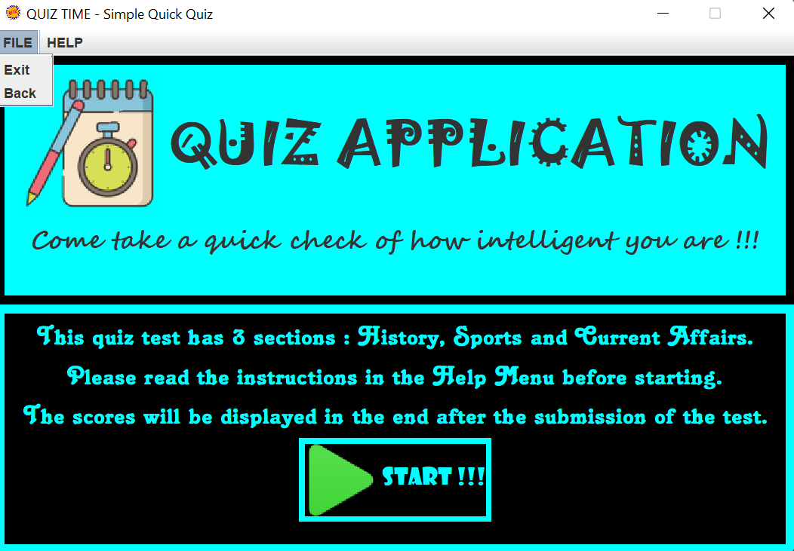

***Choice Frame:***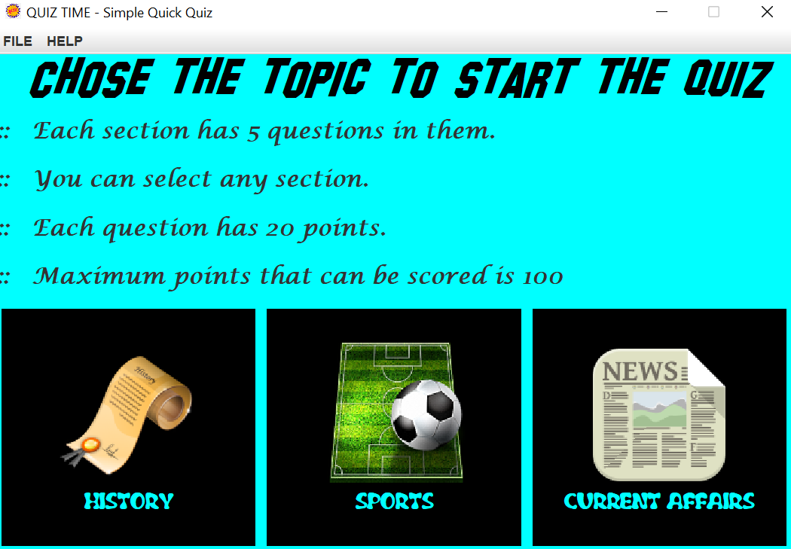

***Instructions in Menu Bar:***

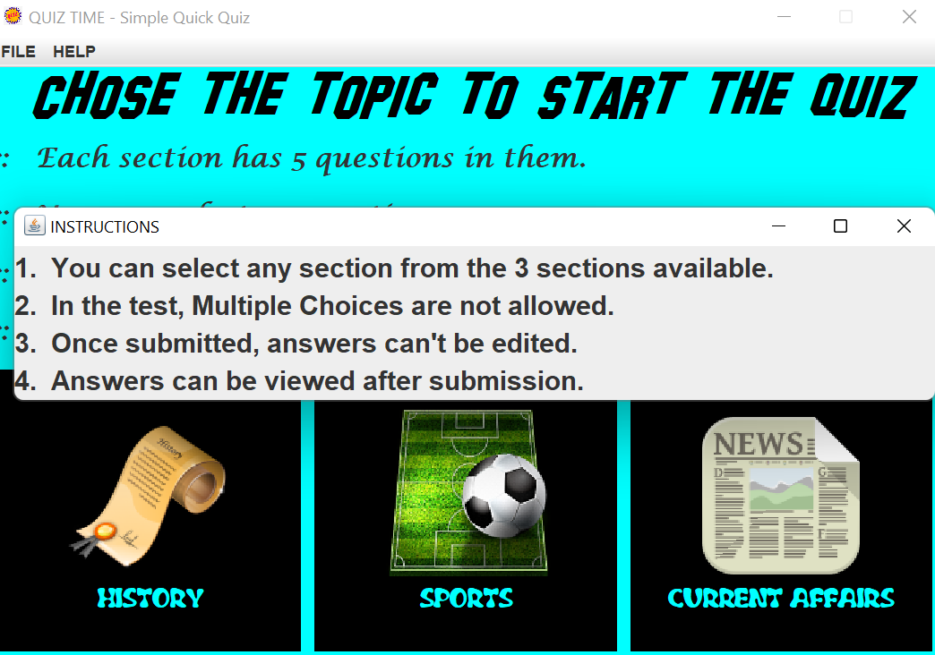

***History Frame:***

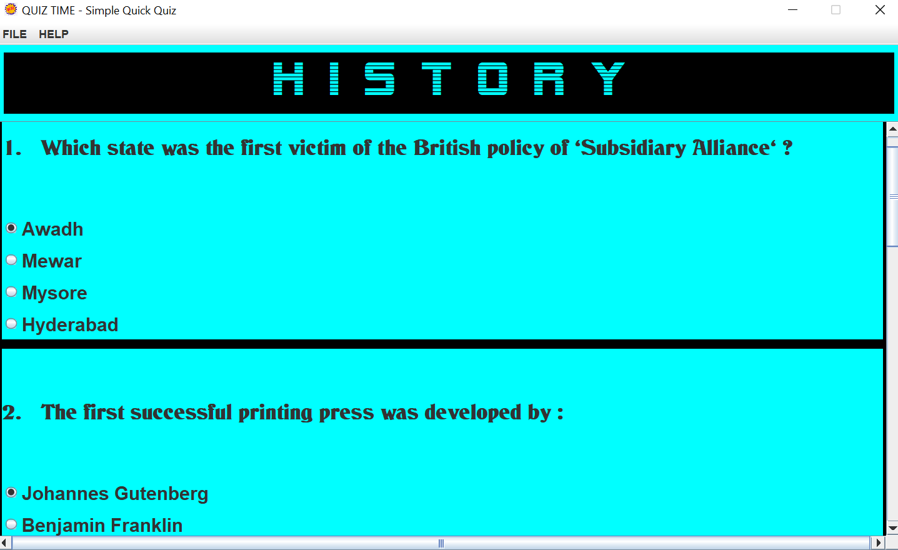

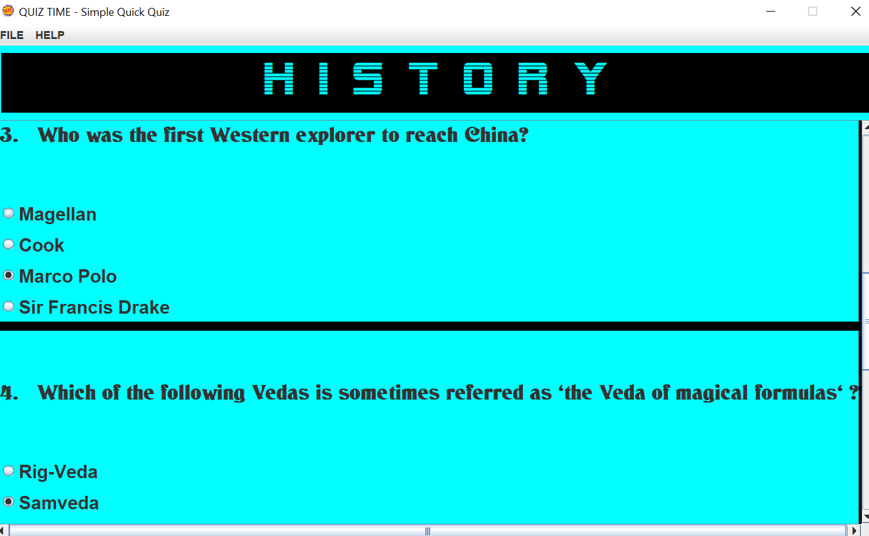

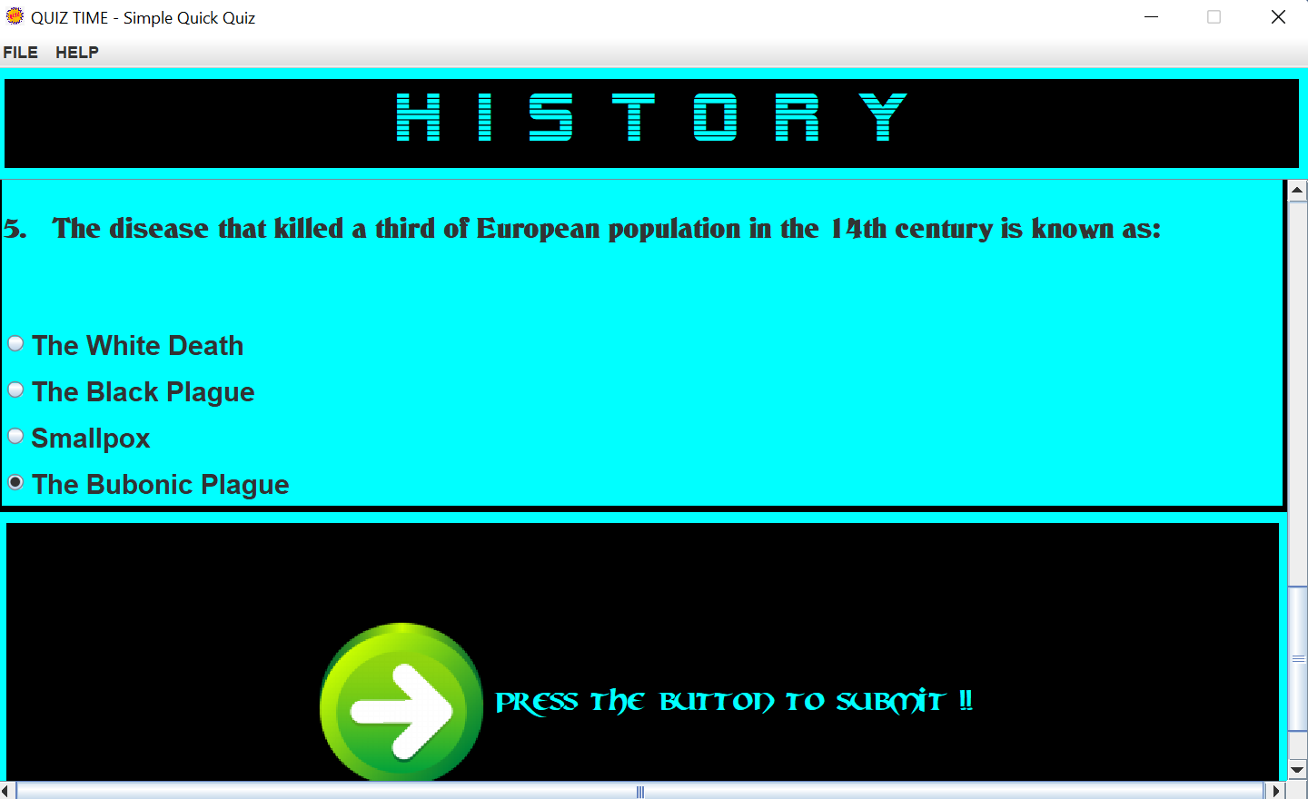

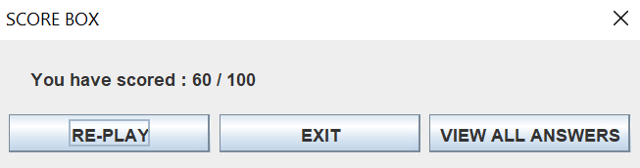

***Sports Frame:***

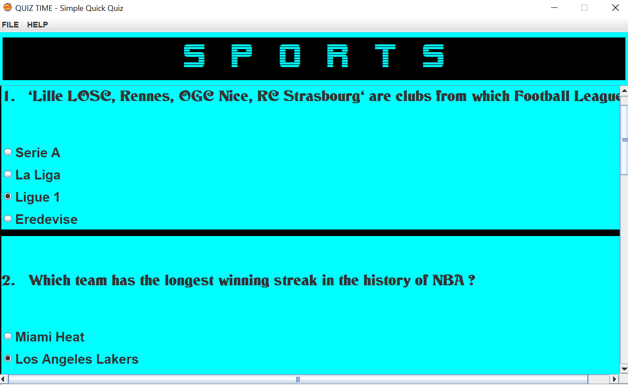

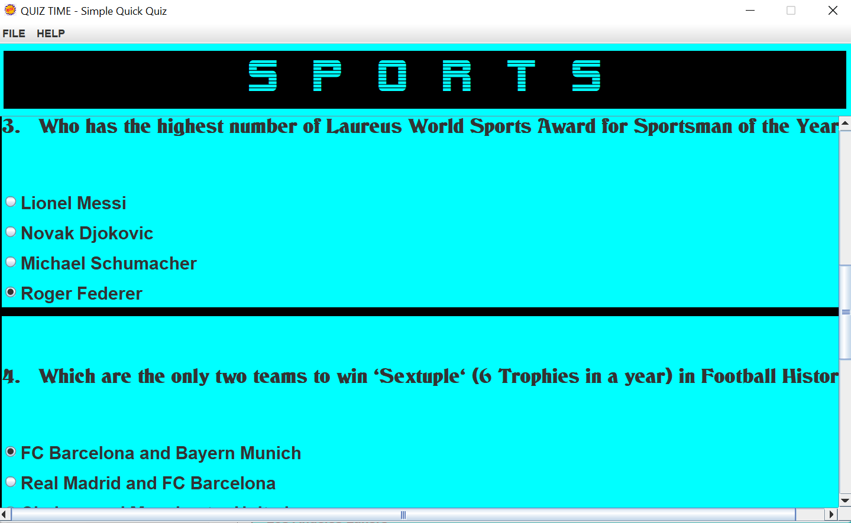

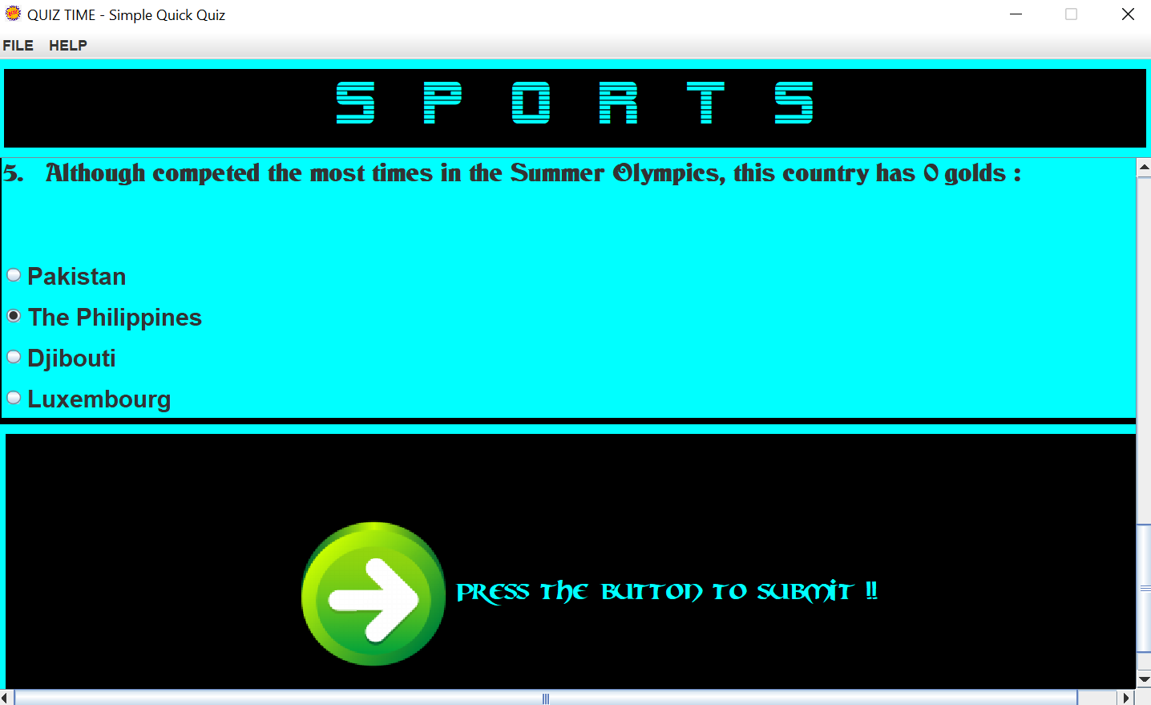

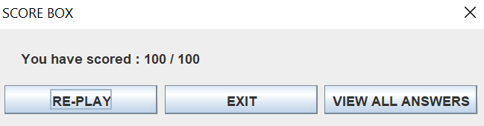

***Current Affairs Frame:***

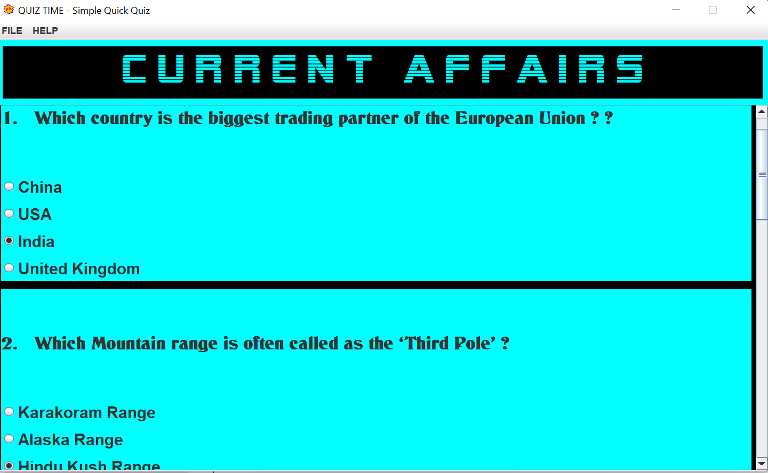

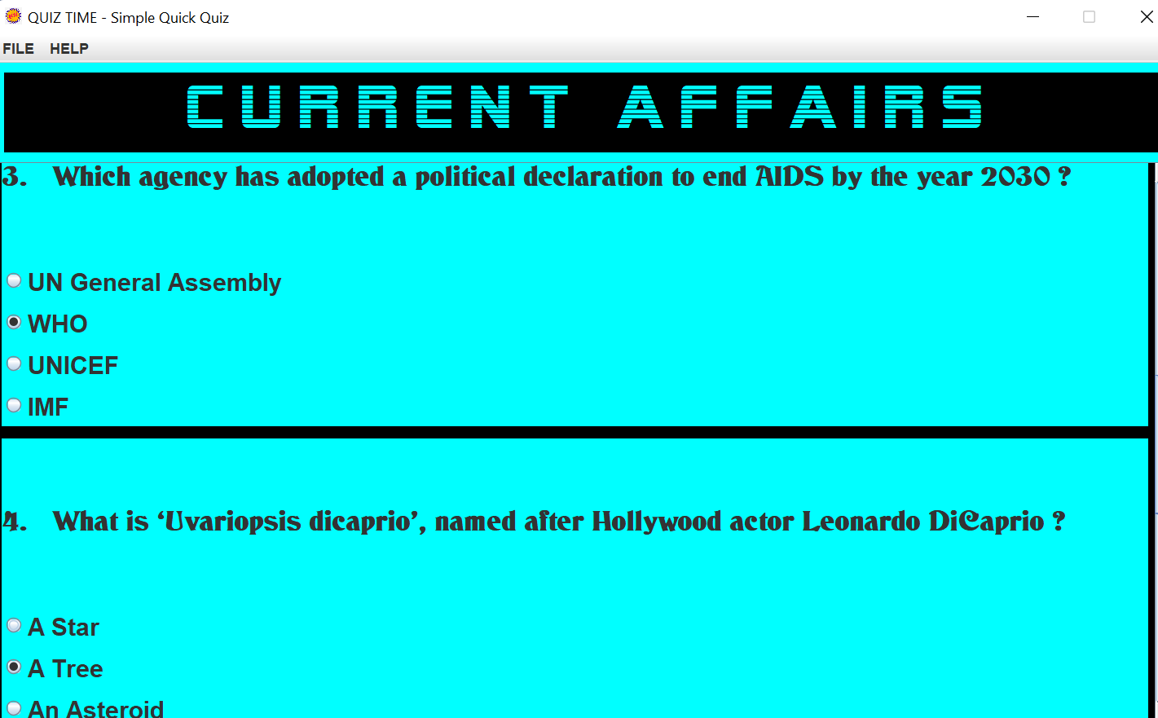

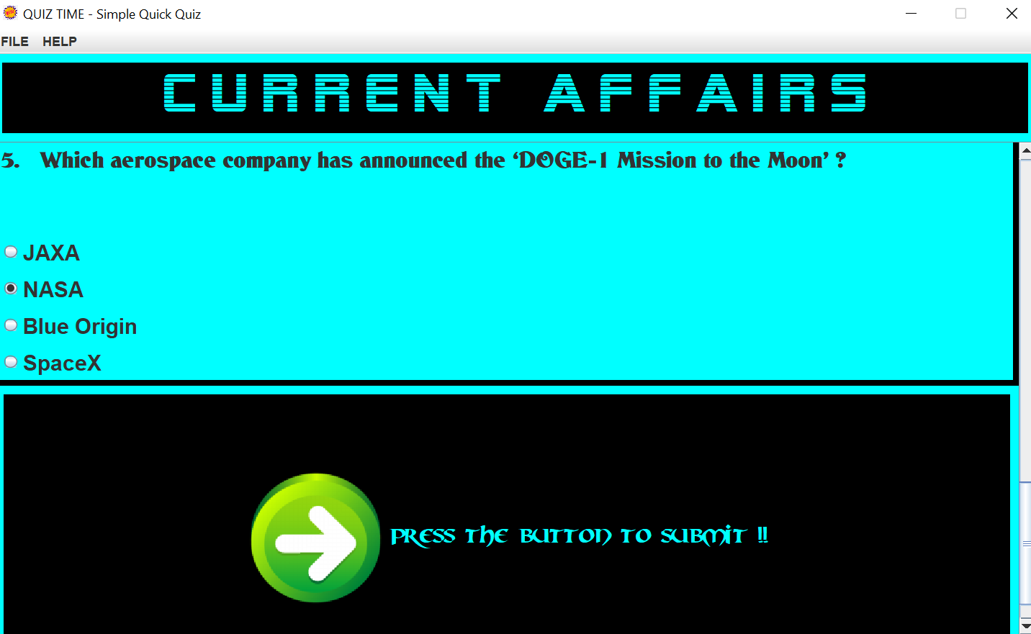

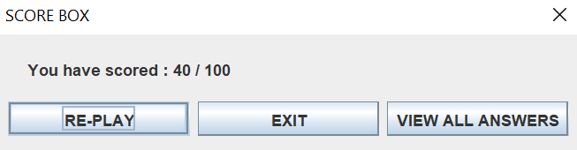

***Answers Frames:***

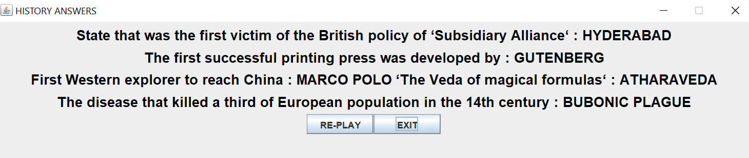

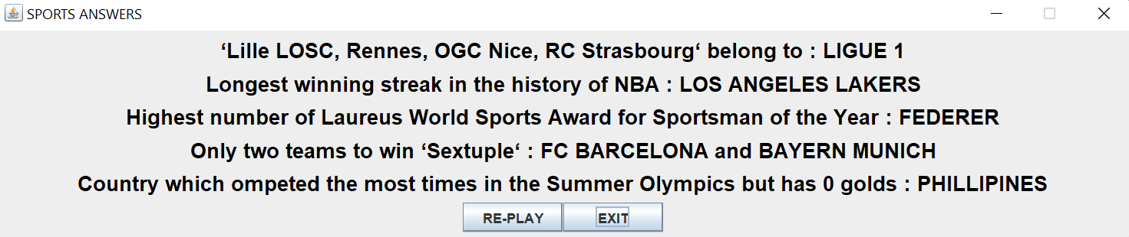

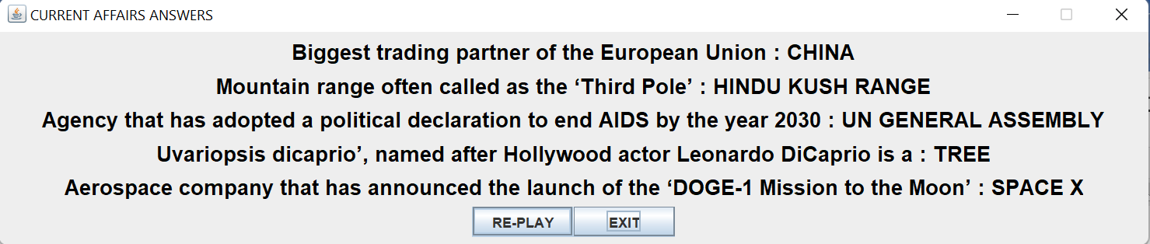

**FUTURE SCOPE:**

Since this is my first year and it was only the ‘basic’ java course, the application I developed is relatively simple. In future, I will try to develop it into a better and stronger application, for example, I’ll try and implement the following:

* Use the concept of *Database Management Syste*m to store the data of every player who plays the game with the scores they obtain.
* Implement the concept of *Timers* so that this test becomes time limited.
* Use *test boxes*, *sliders*, *progress bars*, etc. and make it more efficient.

I’ll also try to find out all the bugs and lags in this application and de-bug them efficiently.

**CONCLUSION:**

From this project, I have:

* Understood concepts like: *Arrays*, *Strings*, *Object*, *Classes & Inheritance*, *Packages and Modules*, *Constructors*, *Methods*, *JSwing* *GUI*, etc.
* Learnt to develop a basic *GUI Application* using *JSwing* and its classes and methods.
* Implemented the learnt skills to innovate and design the frames and tasks.
* Oriented myself to be prepared for future project tasks.

**LINKS** (to access the project):

* **Google Drive:** [*https://drive.google.com/drive/folders/1I2TI_UqW9LMtpnf9DIkq72r3asuM5jmN?usp=sharing*](https://drive.google.com/drive/folders/1I2TI_UqW9LMtpnf9DIkq72r3asuM5jmN?usp=sharing)

-------------------------------T H A N K Y O U-------------------------------